Write a C program to simulate the following contiguous memory allocation techniques.
a) Worst-fit
b) Best-fit
c) First-fit
#include <stdio.h>
void firstFit(int blockSize[], int m, int processSize[], int n) {
int allocation[10];
for(int i = 0; i < n; i++)
allocation[i] = -1;
for(int i = 0; i < n; i++) {
for(int j = 0; j < m; j++) {
if(blockSize[j] >= processSize[i]) {
allocation[i] = j;
blockSize[j] -= processSize[i];
break;
}
}
}
printf("\nFIRST FIT\n");
printf("Process No\tProcess Size\tBlock No\n");
for(int i = 0; i < n; i++) {
printf("%d\t\t%d\t\t", i + 1, processSize[i]);
if(allocation[i] != -1)
printf("%d\n", allocation[i] + 1);
else
printf("Not Allocated\n");
}
}
void bestFit(int blockSize[], int m, int processSize[], int n) {
int allocation[10];
for(int i = 0; i < n; i++)
allocation[i] = -1;
for(int i = 0; i < n; i++) {
int bestIdx = -1;
for(int j = 0; j < m; j++) {
if(blockSize[j] >= processSize[i]) {
if(bestIdx == -1 || blockSize[j] < blockSize[bestIdx])
bestIdx = j;
}
}
if(bestIdx != -1) {
allocation[i] = bestIdx;
blockSize[bestIdx] -= processSize[i];
}
}
printf("\nBEST FIT\n");
printf("Process No\tProcess Size\tBlock No\n");
for(int i = 0; i < n; i++) {
printf("%d\t\t%d\t\t", i + 1, processSize[i]);
if(allocation[i] != -1)
printf("%d\n", allocation[i] + 1);
else
printf("Not Allocated\n");
}
}
void worstFit(int blockSize[], int m, int processSize[], int n) {
int allocation[10];
for(int i = 0; i < n; i++)
allocation[i] = -1;
for(int i = 0; i < n; i++) {
int worstIdx = -1;
for(int j = 0; j < m; j++) {
if(blockSize[j] >= processSize[i]) {
if(worstIdx == -1 || blockSize[j] > blockSize[worstIdx])
worstIdx = j;
}
}
if(worstIdx != -1) {
allocation[i] = worstIdx;
blockSize[worstIdx] -= processSize[i];
}
}
printf("\nWORST FIT\n");
printf("Process No\tProcess Size\tBlock No\n");
for(int i = 0; i < n; i++) {
printf("%d\t\t%d\t\t", i + 1, processSize[i]);
if(allocation[i] != -1)
printf("%d\n", allocation[i] + 1);
else
printf("Not Allocated\n");
}
}
int main() {
int m, n;
int blockSize[10], processSize[10];
int b1[10], b2[10], b3[10];
printf("Enter number of memory blocks: ");
scanf("%d", &m);
printf("Enter sizes of memory blocks:\n");
for(int i = 0; i < m; i++) {
scanf("%d", &blockSize[i]);
b1[i] = blockSize[i];
b2[i] = blockSize[i];
b3[i] = blockSize[i];
}
printf("Enter number of processes: ");
scanf("%d", &n);
printf("Enter sizes of processes:\n");
for(int i = 0; i < n; i++)
scanf("%d", &processSize[i]);
firstFit(b1, m, processSize, n);
bestFit(b2, m, processSize, n);
worstFit(b3, m, processSize, n);
return 0;
}

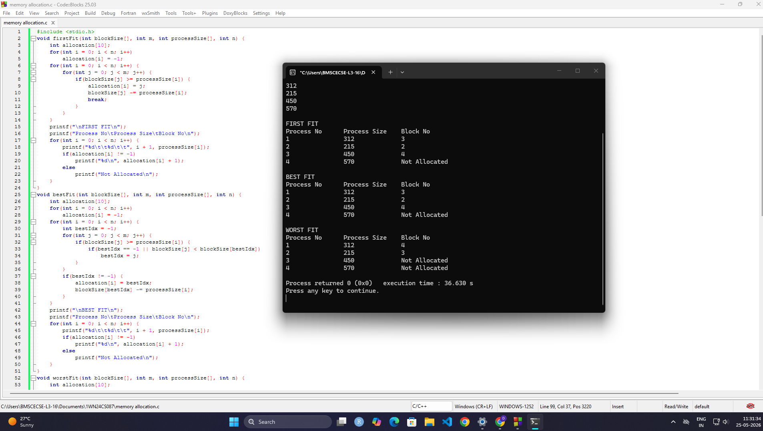
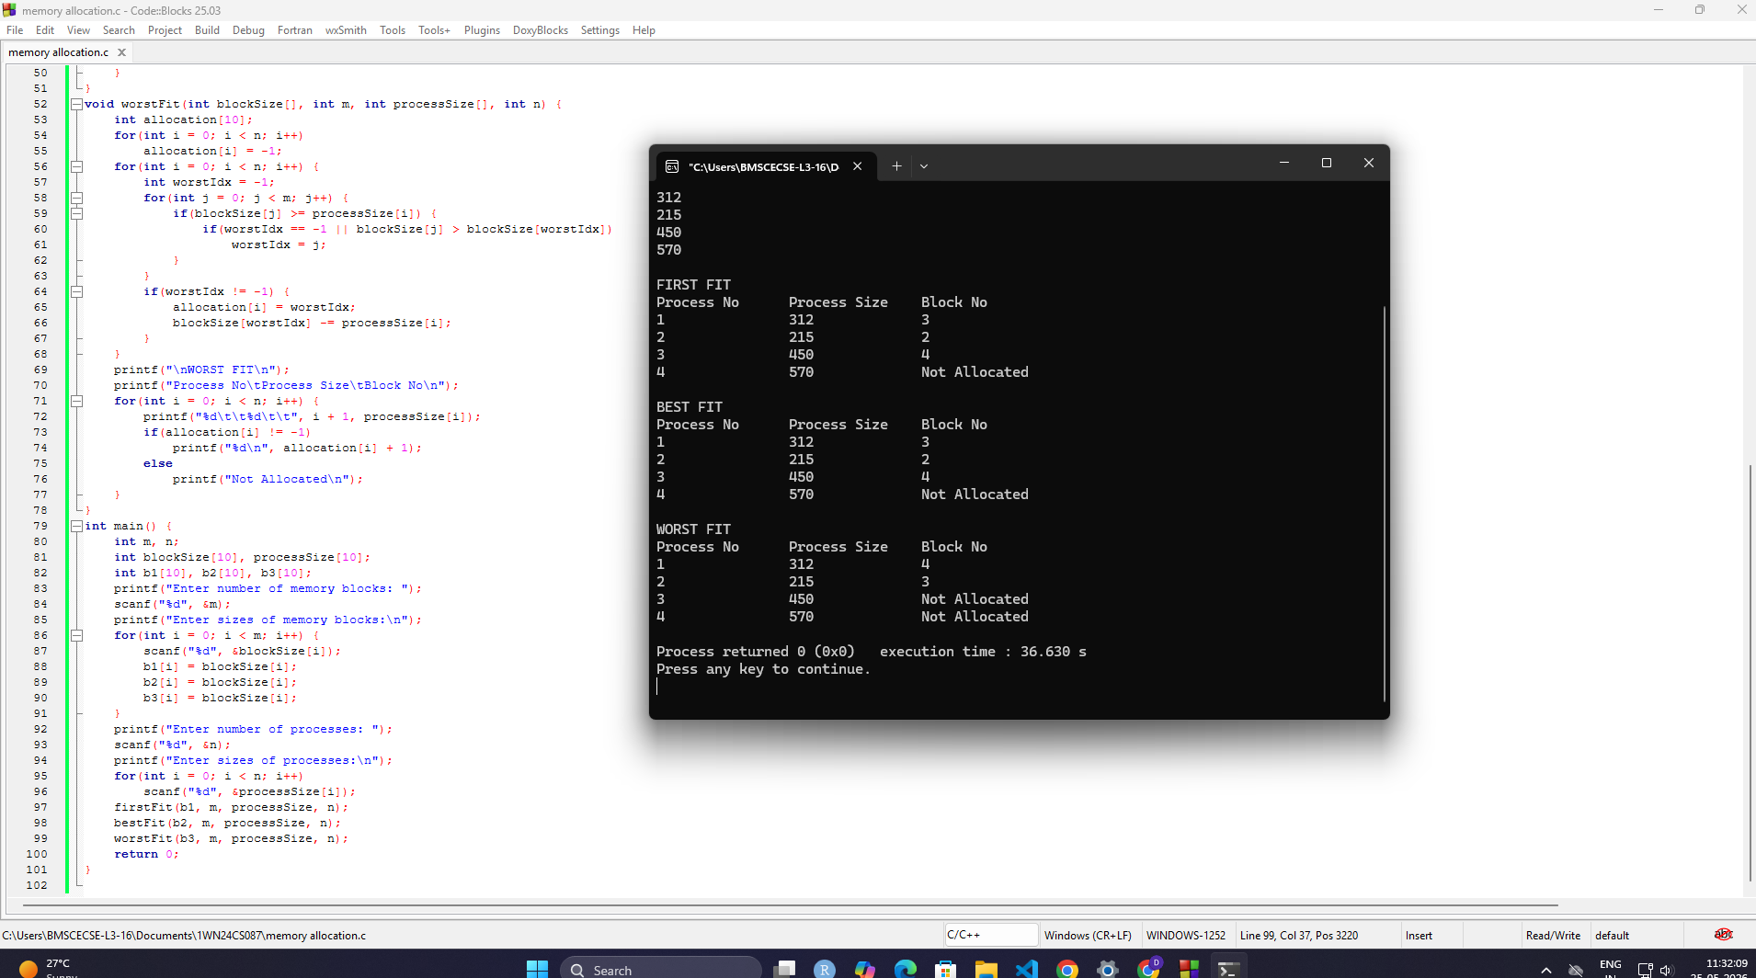

Write a C program to simulate page replacement algorithms.
- FIFO
- b) LRU
- c) Optimal

#include <stdio.h>

int main() {
int frames, n, pages[50];
int fifo[10], lru[10], optimal[10];
int i, j, k, fault;

// INPUT
printf("Enter the number of Frames: ");
scanf("%d", &frames);

printf("Enter the length of reference string: ");
scanf("%d", &n);

printf("Enter the reference string: ");
for(i = 0; i < n; i++)
scanf("%d", &pages[i]);

// ---------------- FIFO ----------------

for(i = 0; i < frames; i++)
fifo[i] = -1;

int index = 0;
fault = 0;

printf("\nFIFO Page Replacement Process:\n");

for(i = 0; i < n; i++) {
int found = 0;

for(j = 0; j < frames; j++) {
if(fifo[j] == pages[i]) {
found = 1;
break;
}
}

if(found == 0) {
fifo[index] = pages[i];
index = (index + 1) % frames;
fault++;

printf("PF No. %d: ", fault);

for(j = 0; j < frames; j++) {
if(fifo[j] != -1)
printf("%d ", fifo[j]);
else
printf("- ");
}
printf("\n");
}
}

printf("FIFO Page Faults: %d\n", fault);

// ---------------- LRU ----------------

int time[10], count = 0;

for(i = 0; i < frames; i++) {
lru[i] = -1;
time[i] = 0;
}

fault = 0;

printf("\nLRU Page Replacement Process:\n");

for(i = 0; i < n; i++) {
int found = 0;

for(j = 0; j < frames; j++) {
if(lru[j] == pages[i]) {
count++;
time[j] = count;
found = 1;
break;
}
}

if(found == 0) {
int pos = 0;

for(j = 1; j < frames; j++) {
if(time[j] < time[pos])
pos = j;
}

lru[pos] = pages[i];
count++;
time[pos] = count;
fault++;

printf("PF No. %d: ", fault);

for(j = 0; j < frames; j++) {
if(lru[j] != -1)
printf("%d ", lru[j]);
else
printf("- ");
}
printf("\n");
}
}

printf("LRU Page Faults: %d\n", fault);

// ---------------- OPTIMAL ----------------

for(i = 0; i < frames; i++)
optimal[i] = -1;

fault = 0;

printf("\nOptimal Page Replacement Process:\n");

for(i = 0; i < n; i++) {
int found = 0;

for(j = 0; j < frames; j++) {
if(optimal[j] == pages[i]) {
found = 1;
break;
}
}

if(found == 0) {
int pos = -1, farthest = i;

for(j = 0; j < frames; j++) {
int flag = 0;

for(k = i + 1; k < n; k++) {
if(optimal[j] == pages[k]) {
if(k > farthest) {
farthest = k;
pos = j;
}
flag = 1;
break;
}
}

if(flag == 0) {
pos = j;
break;
}
}

if(pos == -1)
pos = 0;

optimal[pos] = pages[i];
fault++;

printf("PF No. %d: ", fault);

for(j = 0; j < frames; j++) {
if(optimal[j] != -1)
printf("%d ", optimal[j]);
else
printf("- ");
}
printf("\n");
}
}

printf("Optimal Page Faults: %d\n", fault);

return 0;
}

